Lab 18– API Integration: Connecting to external services with error handling
Name: md nasrin
Enrollment Number: 2503a51l23
Assignment Number:18.2
--------------------------------------------------------------------------------------------------------------------------------------
Lab Question 1 : Weather Forecasting API
Task 1
Prompt:
Write a Python script using the OpenWeatherMap API to fetch and display current temperature and weather description for a given city with error handling for missing or invalid API key.
Code:
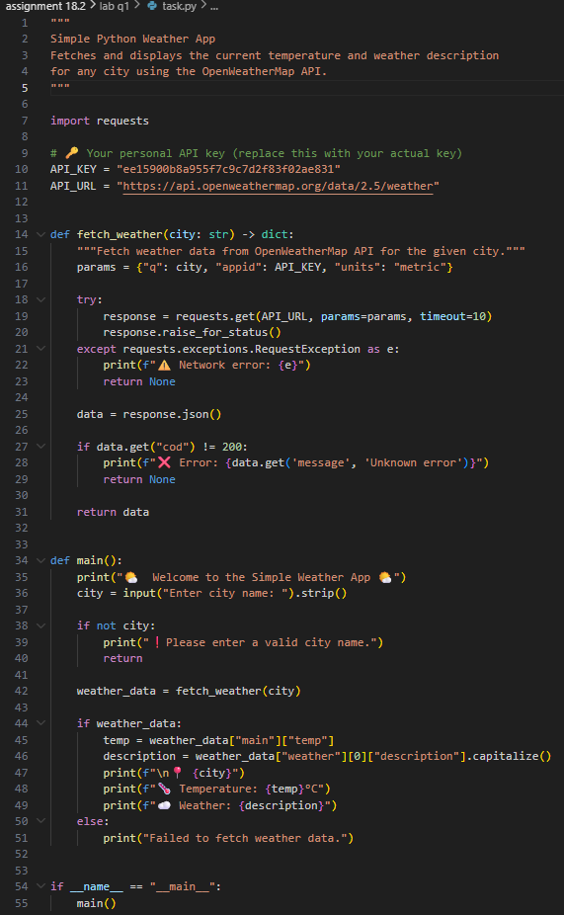

Output:
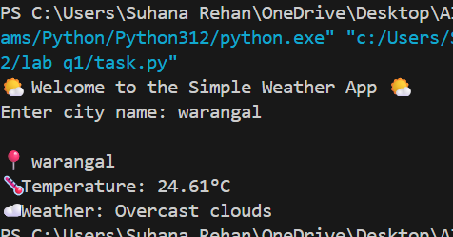
Observations:
- I used AI to help me understand how to send API requests using the requests module.
- It also showed me how to check if my API key is missing or wrong.
- I learned that JSON responses can be accessed like dictionaries in Python.

Task 2
Prompt:
Extend the weather script to save weather data into a CSV file without duplicates and handle file read/write errors.
Code:
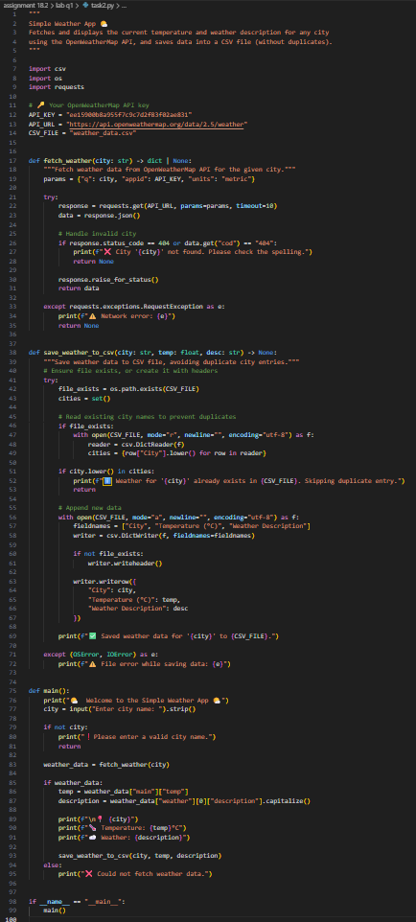
Output:
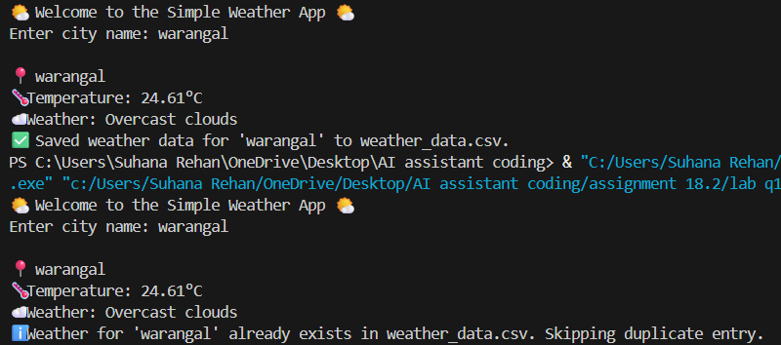
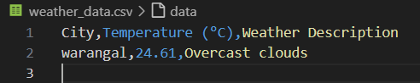
Observations:
- I learned how to use csv.DictWriter to store data safely.
- The AI helped me avoid duplicate city entries by checking before writing.
- I also handled file errors using try and except blocks.

Lab Question 2: Currency Exchange Rate API
Task 1
Prompt:
Write a Python script that takes user input (amount, source, target currency) and fetches the latest exchange rate with error handling for invalid currency codes.
Code:
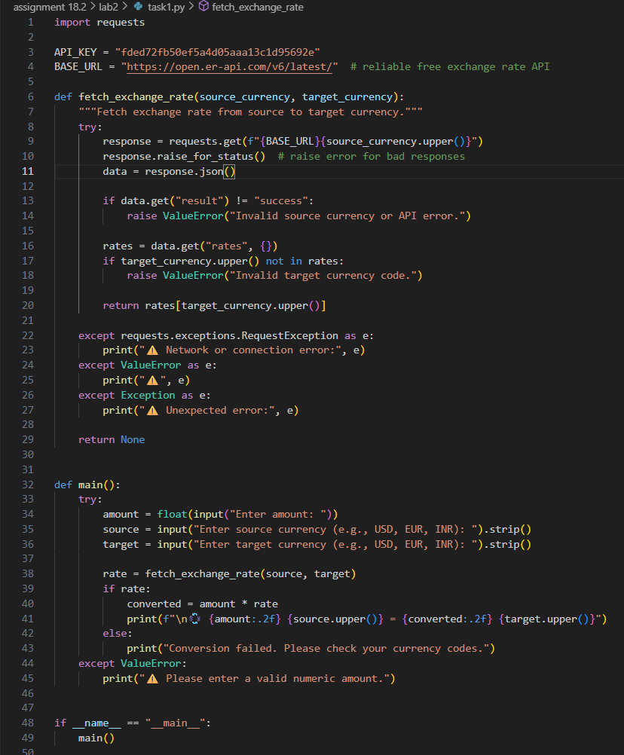
Output:
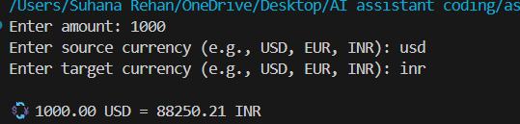
Observations:
- I used AI to help create input prompts and handle wrong currency codes.
- I understood how to check if the API response was valid before using it.
- The script now gives a clear error message when something goes wrong.

Task 2
Prompt:
Add retry logic to the currency script to attempt the API call up to three times if it fails, and log all errors into a local file.
Code:
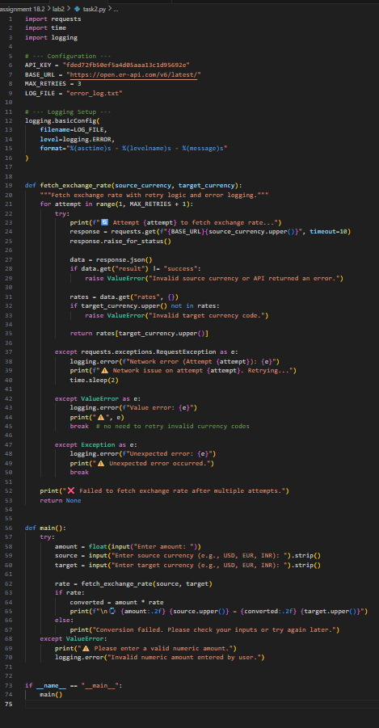
Output:
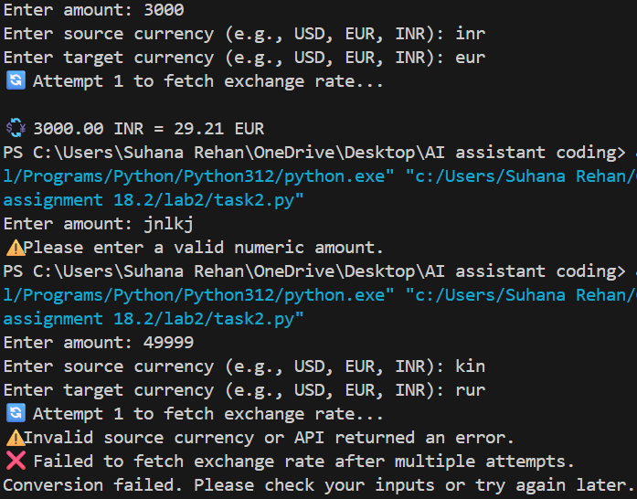
Observations:
- AI showed me how to use a simple retry loop with for and try.
- I created an error log file using basic file handling.
- I learned that logging helps when APIs fail due to server issues.

Lab Question 3 – News Headlines API
Task 1
Prompt:
Write a Python script to fetch and print the top 5 technology headlines from a news API, with timeout error handling.
Code:
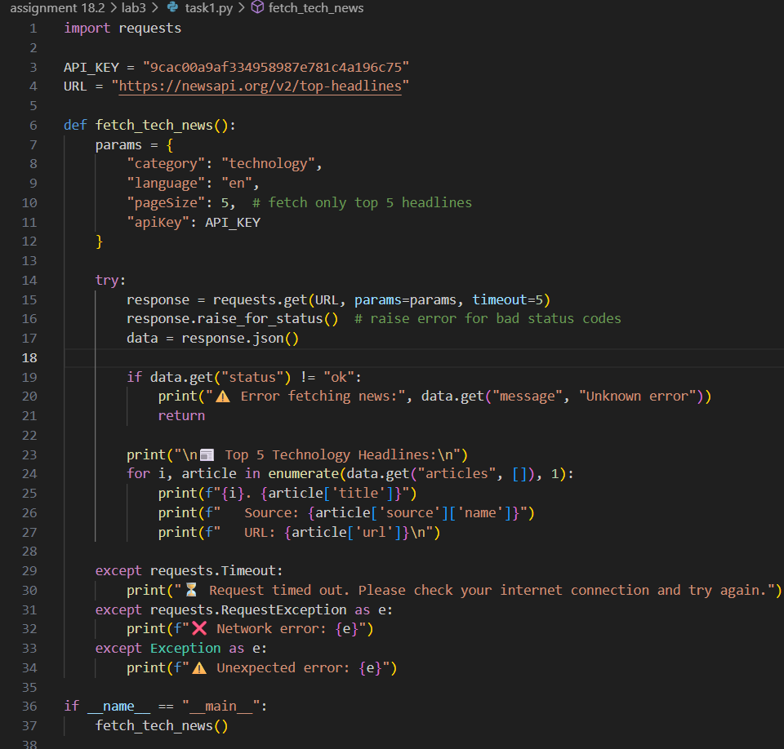
Output:
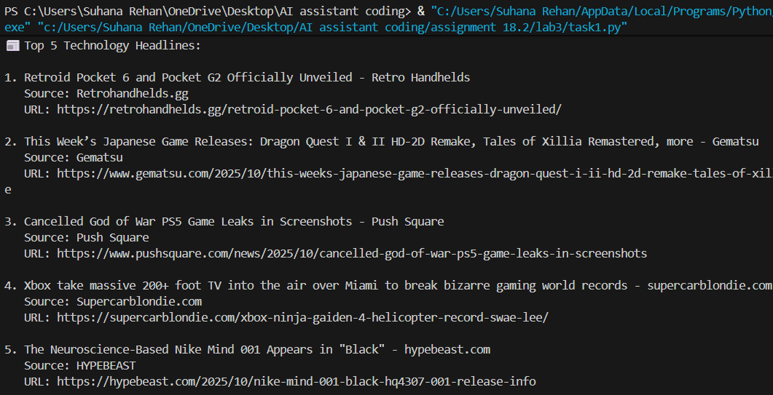
Observations:
- AI helped me understand how to use the timeout parameter in requests.
- The script now prints headlines clearly in the console.
- I learned how to handle slow or failed responses without crashing.

Task 2
Prompt:
Clean and preprocess the headlines by removing special characters and converting them to title case, handling empty or null values.
Code:
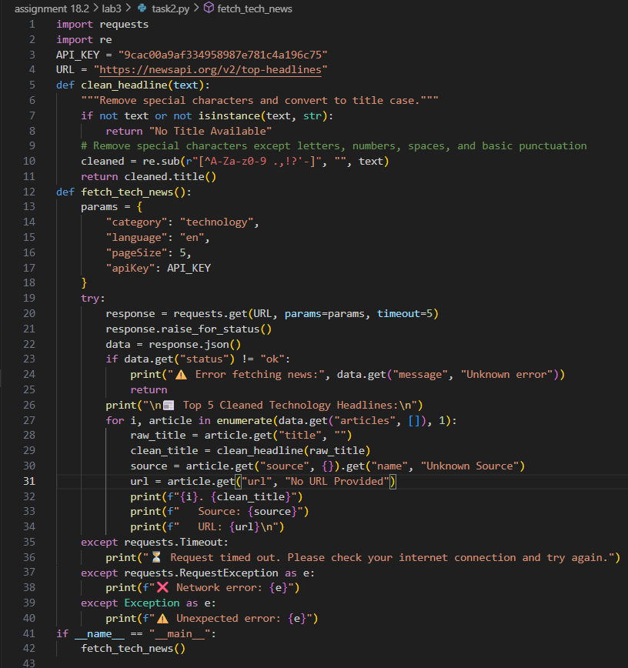
Output:
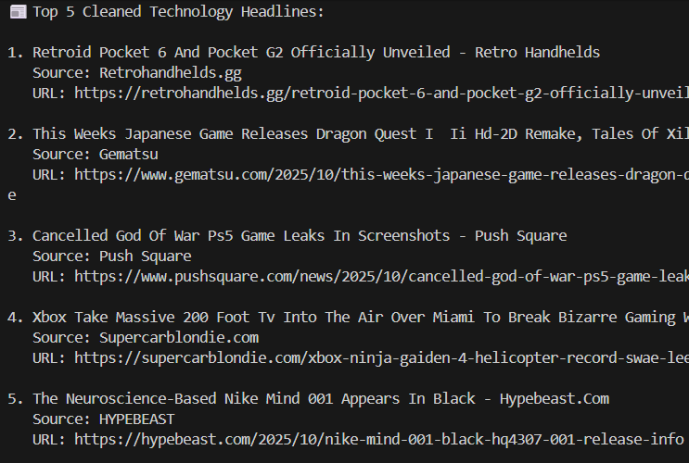
Observations:
- I used AI to clean text using regular expressions and title() function.
- It helped me skip empty or None headlines safely.
- The cleaned headlines look much more readable now.
- -

